Rolling Dice: Introduction to Exponential Functions
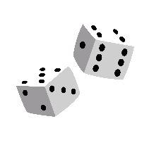

Part 1: Collect Data
Roll Number | Number of Remaining dice
0
1
2
3
4
5
6
7
8
9
10
11
12
13
14
15

- “Roll” 36 Dice
- Remove all dice that show a “4”
- Count how many remain. DO NOT return dice once they have been removed.
- Repeat this process until no dice remain or you have “rolled” them 15 times, whichever comes first.

Part 2: Graphing on Desmos
- Open the Desmos app
- Click the “+ “ sign and select table
- Zoom in and out (+ or – on graph) so that you can see all points

Part 3: In a Perfect World
Side of a dice
Probability of rolling that side

Step away from the literal dice, allowing for fractional quantities to remain (half or a quarter of a dice). Fill in the T-Table to determine the expected number of remaining dice. HINT: Think about how many were left after each roll?
Roll Number | Expected number of remaining dice | Multiply | Expand
0
1
2
3
4

Part 4: Making the Connection
- Based on the pattern you observed in Part 3, create an equation to represent the situation.
- Open the app Desmos app. Click the “+ “ sign and select expression. Enter the equation you created in part 3. How does it compare with the points you graphed from part 2?
- In terms of the dice activity, what is the physical meaning of the 36 in your equation?
- How is the 36 related to the graph of the curve?
- What do the other numbers in your equation represent?
- How will the fraction change if you took out 3’s and 4’s? How would the equation change? How would the graph change?

